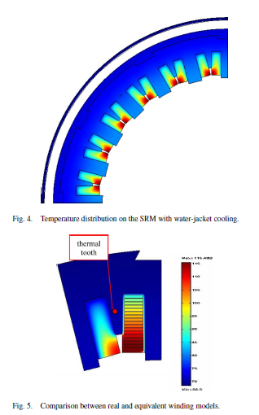

Since the copper–iron thermal resistance is the largest one in the thermal equivalent circuit of the machine, the reduction of the temperature gradient between copper and iron significantly reduces the total temperature gradient between the copper and the cooling fluid. For this reason, an auxiliary “thermal tooth” (Fig. 5) made of iron has been inserted to fill the triangle area: The iron triangles increase the thermal contact surface, improving the heat transmission through the coils sides, with only a little influence in torque production, if the height of a thermal triangle is sufficiently small.

[Tenconi, A., Profumo, F., Bauer, S. E., & Hennen, M. D. (2008). Temperatures evaluation in an integrated motor drive for traction applications. *IEEE Transactions on Industrial Electronics*, *55*(10), 3619–3626. https://doi.org/10.1109/TIE.2008.2003099]

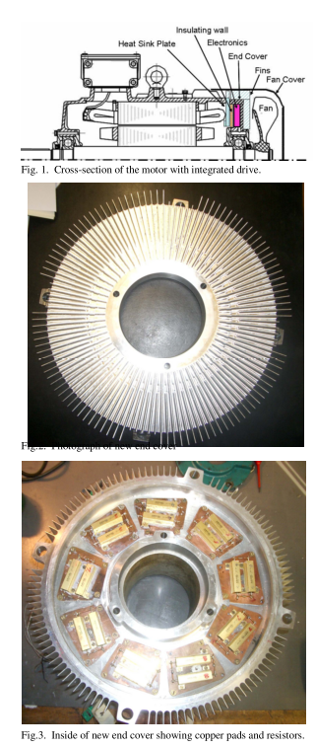

The thermal sink is common to all heat sources (Motor & Power Electronics).

In parallel configuration, the thermal flux paths are independent and do not influence each other. In practice, when the two heat sources are in close proximity this may require some thermal isolation.

Thermal isolation layer must be inserted to stop any thermal interference from the end-winding losses.

Series configuration would be difficult to achieve since the thermal gradient between the machine and the power electronics must be carefully managed so as not to overheat the devices.

The annular region surrounding the bearing housing on the end cover at the fan-end of the motor probably will be selected as being the most suitable for the drive components. Because the advantage that a flat area could be created to mount the components that could be largely isolated thermally from the rest of the motor and that could easily be cooled by air from the fan.

To prevent over heating of the end windings, an additional heat sink plate must be manufactured to fit between the end cover and the frame of the motor to conduct heat from the end region.

This heatsink plate effectively performed to replace the end cover in dissipating heat from the end region of the motor.

[Pickering, S., Thovex, F., Wheeler, P., & Bradley, K. (2006). Thermal Design of an Integrated Motor Drive. *IECON 2006 - 32nd Annual Conference on IEEE Industrial Electronics*, 4794–4799. https://doi.org/10.1109/IECON.2006.348109]

Power Electronics

Motor

Parallel Configuration

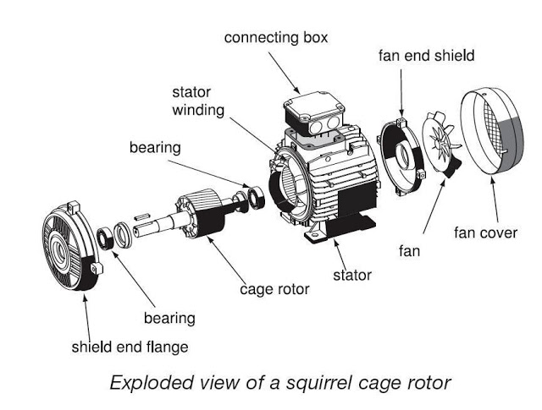

Thermal Insulation Layer

End Windings + Heatsink plate of the motor

Power Electronics

Fan end shield

Variables:

* Fin density & length in the direction of the flow
* Fan Flow rate (velocity)
* Diameter of the heatsink in the direction perpendicular to the flow

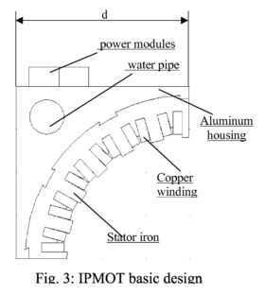

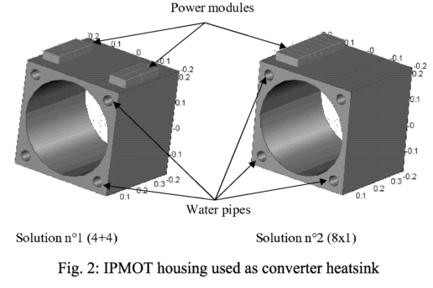

* Uses a rectangular profile machine with sunken cooling pipes in the machine core-back.
* The purpose of the flat edge profile of the machine is to provide a fixing surface directly on the machine body for the power electronic components.

[Farina, F., Rossi, D., Tenconi, A., Profumo, F., & Bauer, S. E. (2005). Thermal design of integrated motor drives for traction applications. *2005 European Conference on Power Electronics and Applications*, 1–10. <https://doi.org/10.1109/EPE.2005.219711>]

PLAN:

1. Build a steady-state lump parameter circuit & simulate.
2. Determine a Rth value.
3. Design an annular heatsink by determining the critical parameters.
4. Simulate the heatsink by using thermal simulation software.